**The Hoops Academy**

**Basketball League Database**

**Table Of Contents**

Part One.........................................................................................................................................3

Summary............................................................................................................................3

Stakeholders......................................................................................................................3

Business Rules....................................................................................................................3

Data Questions...................................................................................................................4

Conceptual Model..............................................................................................................4

Logical Model.....................................................................................................................5

**Part One**

**Summary:**

The Hoops Academy is hosting a youth basketball league this year. The league consists of various age groups and skill levels. The academy would like to manage and track basic team and player statistics from the league for the use of analysis for coaches. Additionally, individual awards will be presented to players from each league at the end of the season based on statistical performance. To assist with statistical team and player tracking for each game, the academy would like a database to be built.

**Stakeholders:**

* Company management
  + People who are in management positions at the Hoops Academy
* Coaches
  + Coaches of each basketball team

**Business Rules:**

* The league consists of 10 teams.
* The season will last 10 weeks.
* Each team will play one game every week against one other team from the league.
* Each team consists of 10 players.
* Each team may have two coaches – a head coach and an assistant coach. Each coach can only coach one team.
* A player must be assigned one of five positions – point guard, shooting guard, small forward, power forward, and center.
* Basic basketball statistics will be tracked and recorded each game for both teams and players.

**Data Questions:**

* Which players belong to each team?
* What are the physical attributes of each player?
* What was the outcome of every game, and which teams were involved?
* Which players performed the best on average across the major statistical categories (points, field goal percentage, 3 point percentage, free throw percentage, assists, blocks, steals, and so forth)?
* Which teams performed the best on average across the major statistical categories?
* Which teams performed the best according to their wins and losses?

**Conceptual Model:**

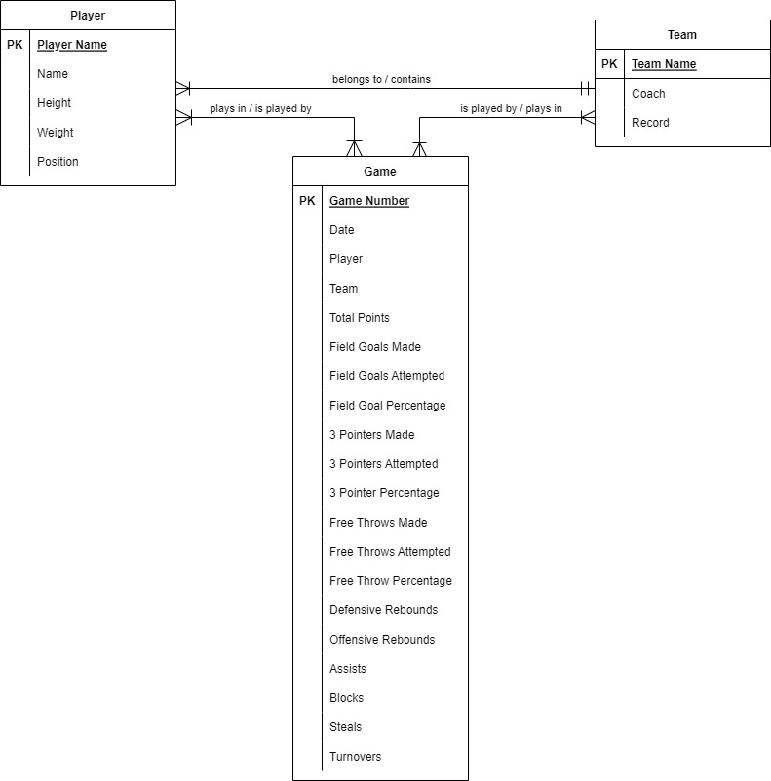

**Logical Model:**